SpendWise: A Simple Backend Learning Project
Ideation Phase
Brainstorm & Idea Prioritization

Date | 09/03/ 2026
Team ID | SWTID-2026-4275
Project Name | SpendWise
Maximum Marks | 4 Marks

Brainstorm & Idea Prioritization Template:
Brainstorming is a collaborative process where team members generate and share ideas to solve a problem. In the SpendWise project, the team focuses on identifying simple and practical ideas that help beginners learn backend development. All ideas are first listed, then grouped based on similarity, and finally prioritized based on feasibility, simplicity, and usefulness for beginner learners.

Step-1: Team Gathering, Collaboration and Select the Problem Statement
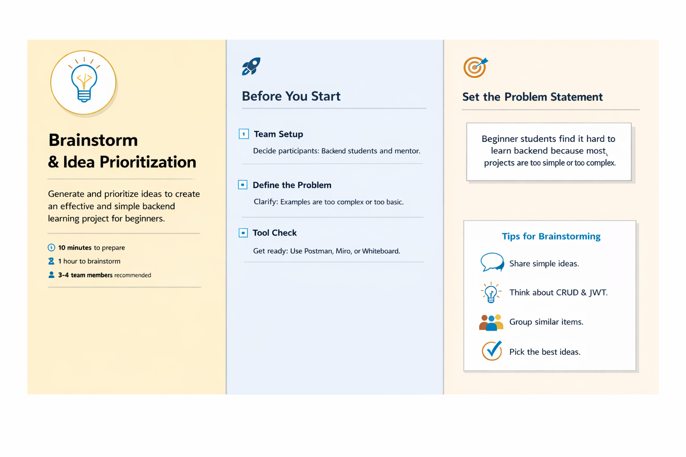

Step-2: Brainstorm, Idea Listing and Grouping
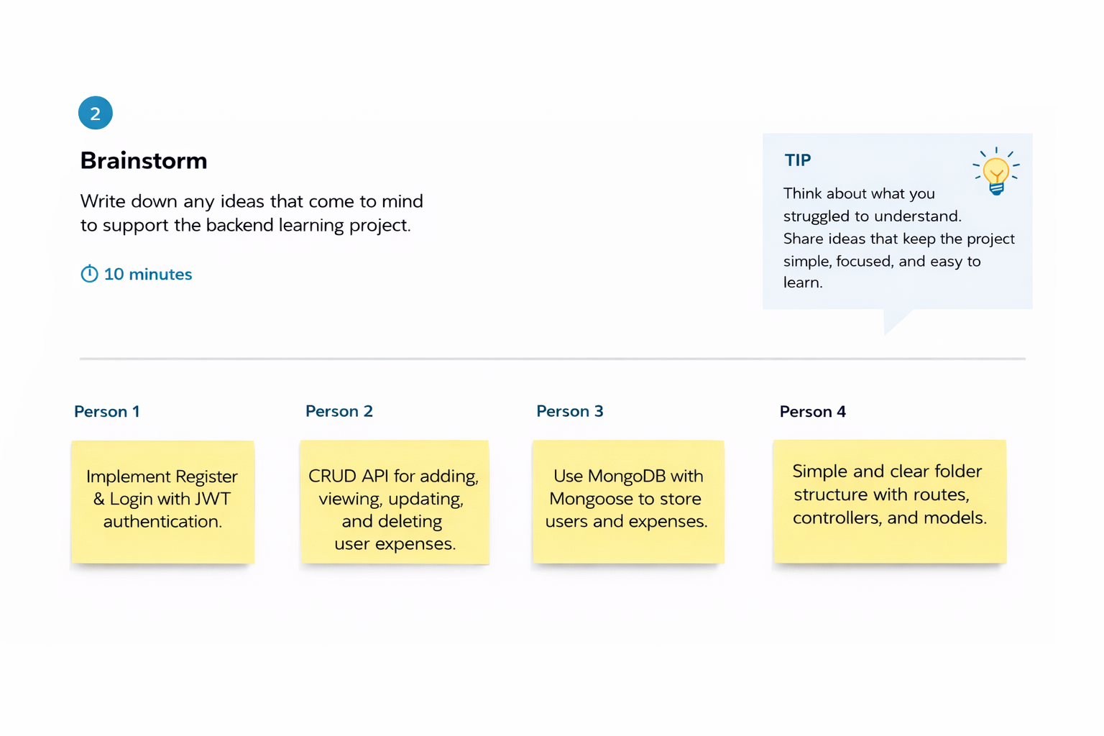
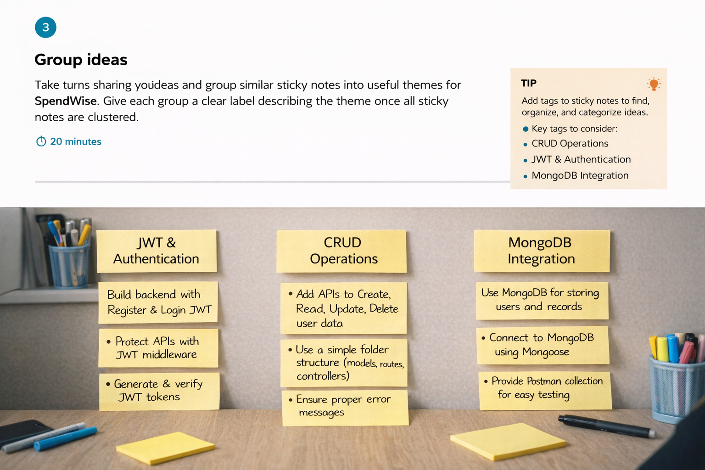

Step-3: Idea Prioritization
